First model we processing and analysis smoke data then using ML algorithms to predict there is fire or not.

Steps

1. Processing

-Checking nulls

- Checking duplicated

-Checking correlation

-checking outliers and drop outliers

2-visulization

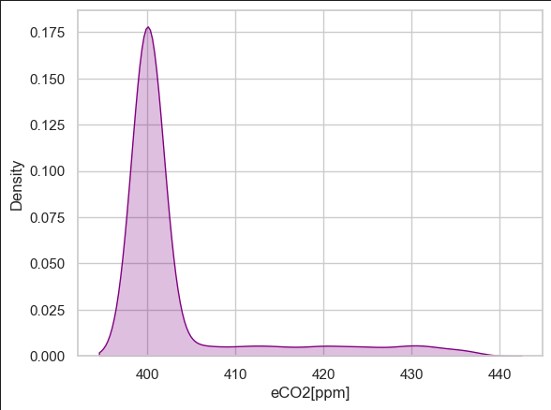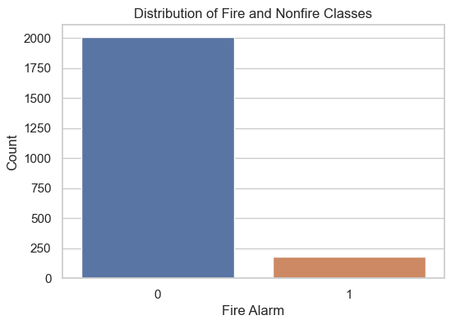

3-Implement ML Algorithms

* Logistic Regression
* KNN
* Decision Tree

Logistic Regression was The Best Model

Others have over fitting

4-Deployment

Second model we processing and analysis (fire& non fire images) then using CNN algorithms to predict there is fire or not.

Steps

1. Processing

* Handle image dimensions

2-visulization

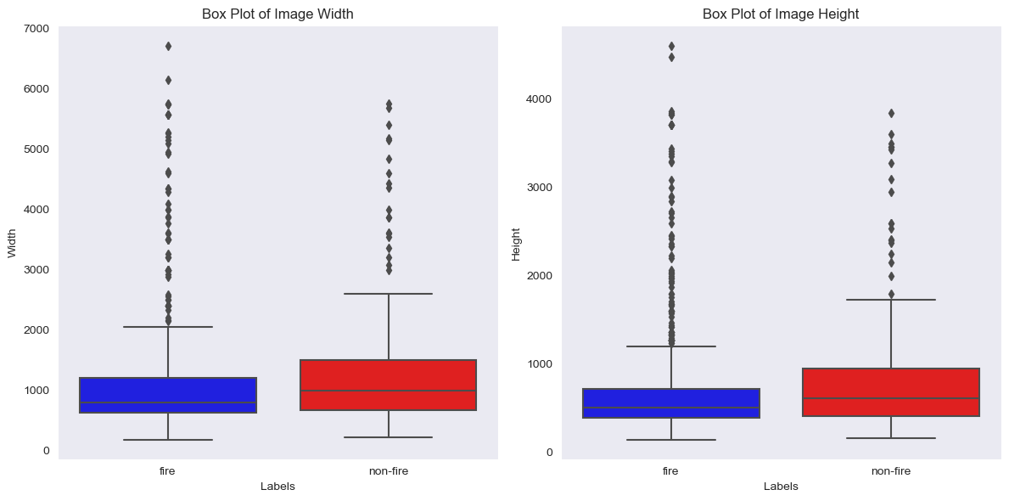

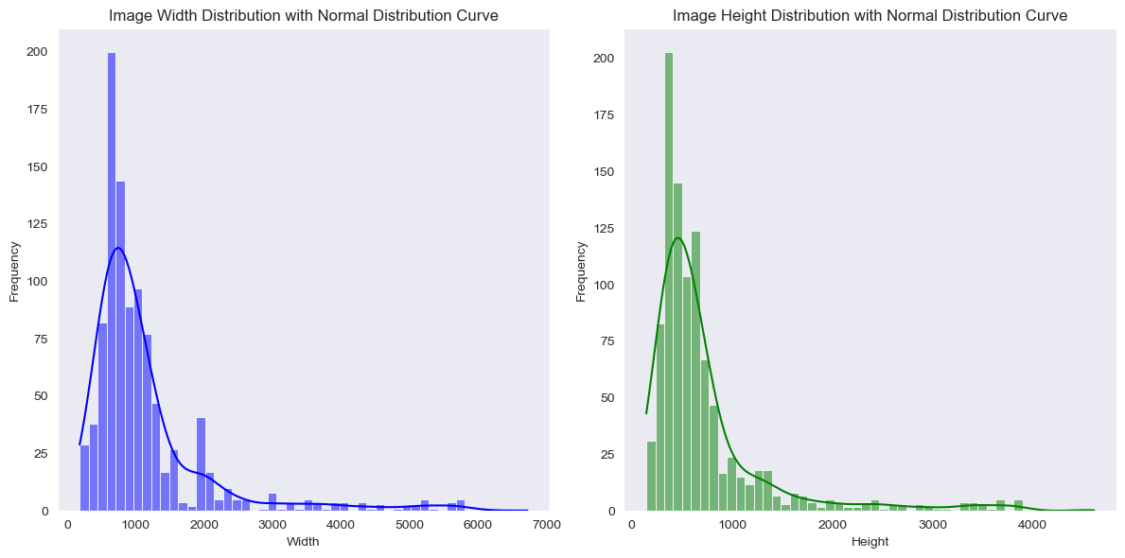

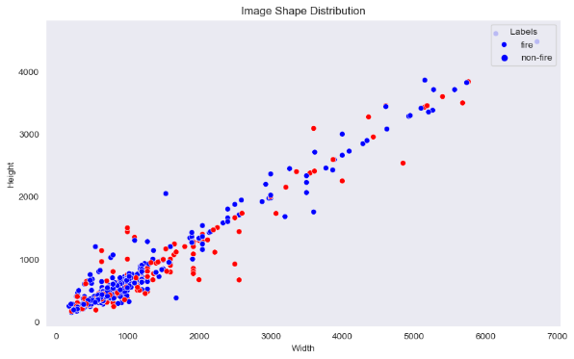

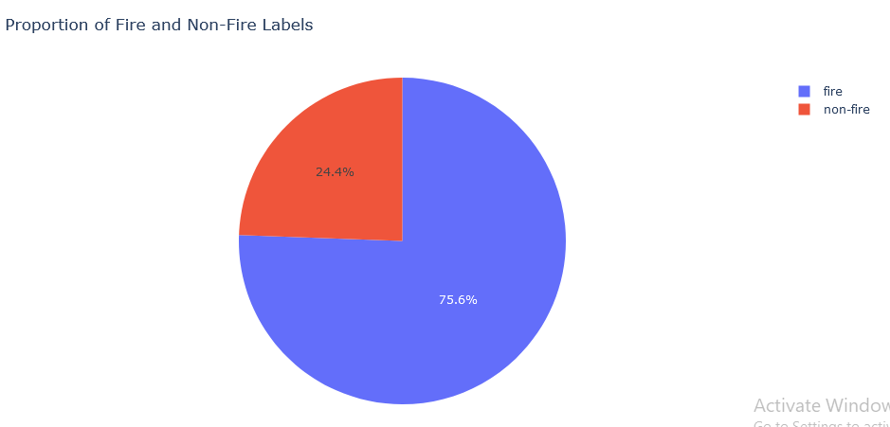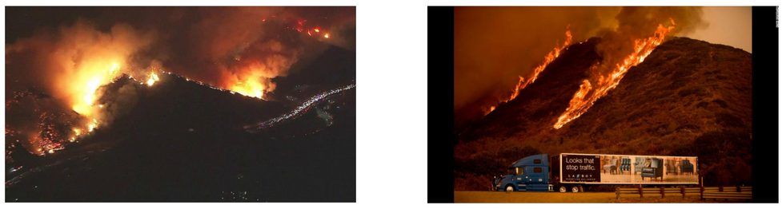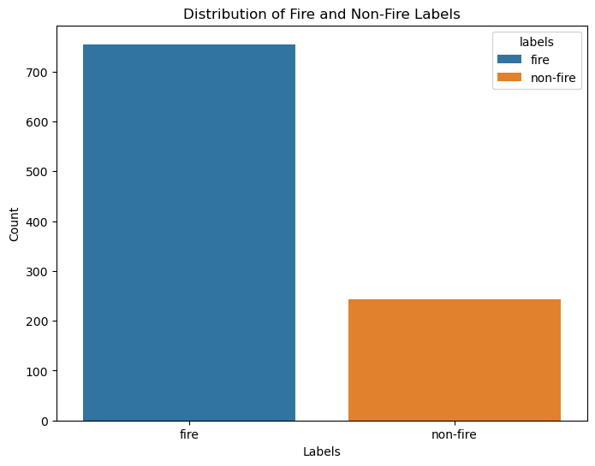

3-CNN Model

4-Deployment